[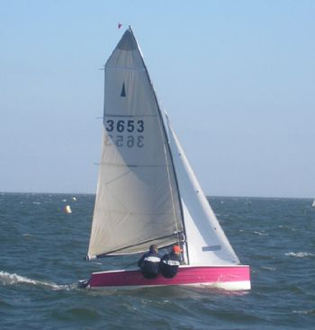](https://www.yachtsandyachting.com/photo/24193)